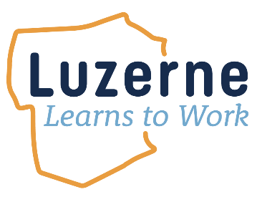
Timeline and Lesson Plan

Luzerne Learns to Work Timeline

Luzerne Learns to Work Lesson Plan
Learning Objectives
At the end of this training, teachers will be able to:
- Provide students with an overview of Luzerne Learns to Work.
- Help students navigate the Luzerne Learns to Work portal.
- Instruct students on creating accounts with PA CareerZone, AMA MicroCourses, PA CareerLink®, and sign up for a local library card.
- Explain and help students navigate the career interests assessment through PA CareerZone.
- Assign relevant career paths and coursework to students.
- Track student progress as they complete courses throughout the academic year.
- Overview of Luzerne Learns to Work
- Explain the background to Luzerne Learns to Work and why this program is in place. (3 minutes)
- Luzerne Learns to Work is a program that gives Luzerne County high school students the power to explore potential career pathways through free access to AMA MicroCourses, Metrix Learning video courses, Luzerne County Library courses, several local workforce and career development tools, and work-based learning experiences with local companies. This document focuses on the process for 11th and 12th grade students.

- Explain the steps of the program (5 minutes):
- Students will take a career interests inventory, which is an assessment to match students to potential career opportunities based on their interests.
- Through this inventory, students will learn what career clusters (industries) align with their interests.
- Students will then take courses through the Luzerne Learns to Work portal (Learn More) to develop the soft skills and professional development skills needed in those career clusters. Optional courses are made available through Metrix Learning/PA CareerLink®, and the Luzerne County library system.
- Students will then interact with the Luzerne Learns to Work website to explore and apply to participate in local work-based learning experiences to see real-world applications and future pathways with local industries.
- Before completing the program, students will explore continuing education opportunities to help them obtain any degrees and certifications needed to pursue those career opportunities. Students can also apply for the Luzerne Learns to Work Scholarship at this time.

- Navigating and exploring the Luzerne Learns to Work Portal
  - Have students go to the Luzerne Learns to Work website Luzerne Learns to Work
  - On the homepage, students will learn more about the Luzerne Learns to Work program and get started with the process.
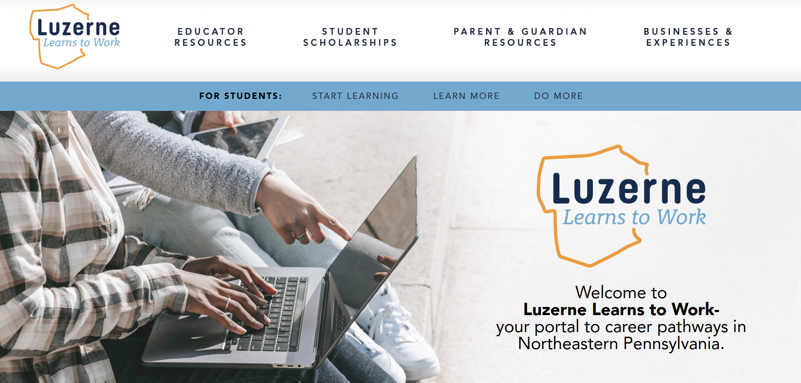
  - The three sections on the portal are “Start Learning,” “Learn More,” and “Do More.” Explain each of these sections to the students.
        - Start Learning will contain an overview of the Luzerne Learns to Work program, information on how to navigate the Luzerne Learns to Work portal, and background and videos on career clusters and in-demand careers available locally.
        - Learn More will explain how to complete a personalized career assessment and get started on their career interest assessment and student-specific learning pathways. In this step, students will also explore continuing education opportunities in these fields.
        - Do More outlines the database of work-based learning experiences offered by local employers. Students will attend these work-based learning experiences after completion of their learning pathways.

- Sign-Up for Accounts
- Luzerne Learns to Work will mostly be facilitated through PA CareerZone, the Luzerne County Library System, AMA MicroCourses through EBSCOlearning, and Metrix Learning through PA CareerLink®.
- Before beginning, students will need to create accounts with each of these resources. It will be necessary to explain each of these resources and a step-by-step on the sign-up process.
- We suggest splitting up the registration for each of these platforms into different sessions (perhaps four sessions held on four days, or in a shorter timeframe if time permits).

The Luzerne Learns to Work Process
- Account Sign Ups
Pennsylvania CareerZone and Career Assessment (30-40 minutes)
- PA CareerZone is a career exploration and planning system designed especially for students. It is a program of the Pennsylvania Department of Education.
- To sign-up for PA CareerZone:
  - Go to PA CareerZone
  - Click on the “Create a free account” or “Register Now” buttons. Complete the short sign-up.

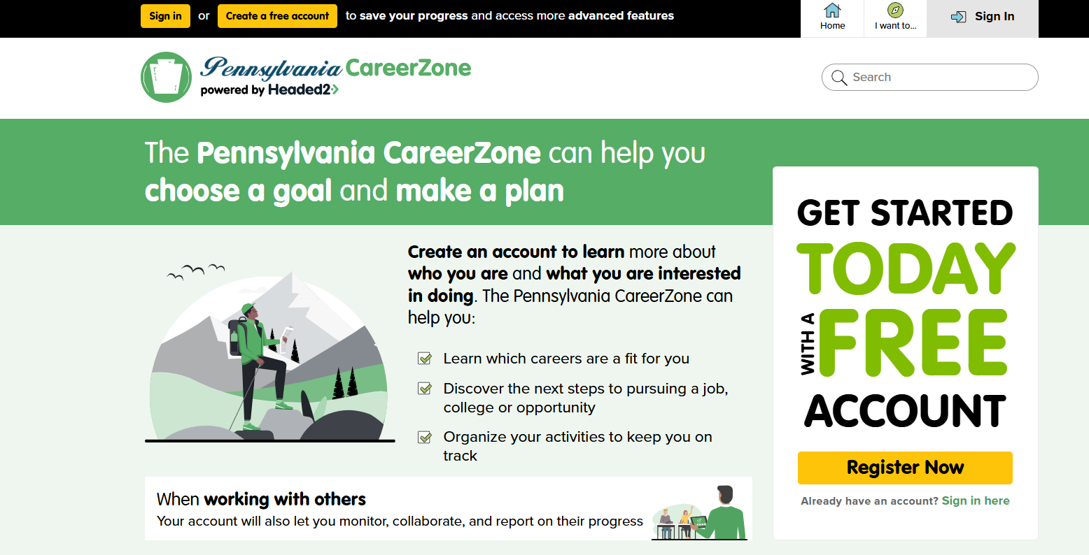
- To access the interest assessment:
  - Log in to the PA CareerZone website.
  - From the main home page, click on “I want to…” on the upper menu bar.

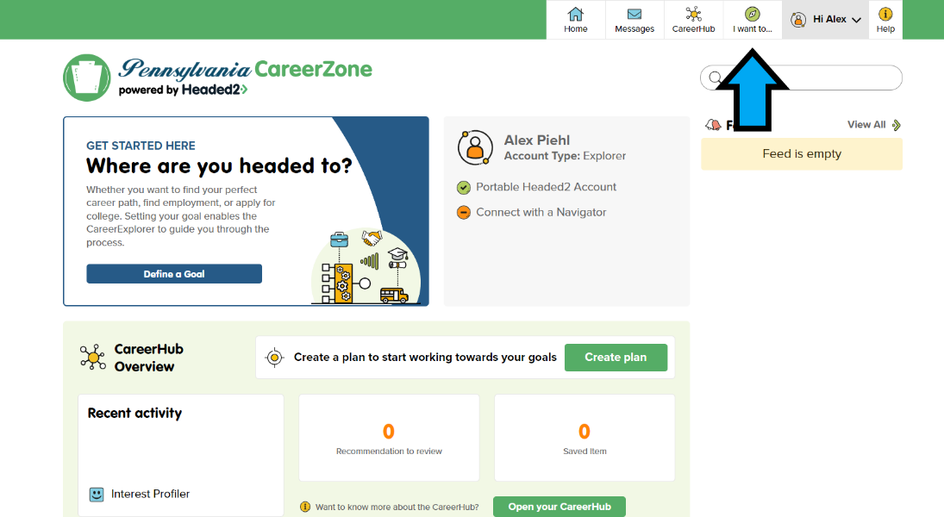

  - Click on “Interest Profiler” found under the “Activities” header.

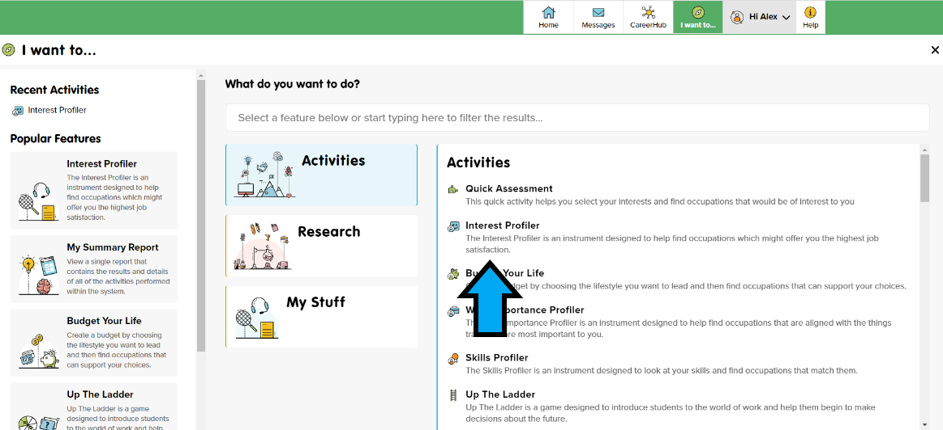

  - Click “Go” found next to “Start a new Interest Profiler”

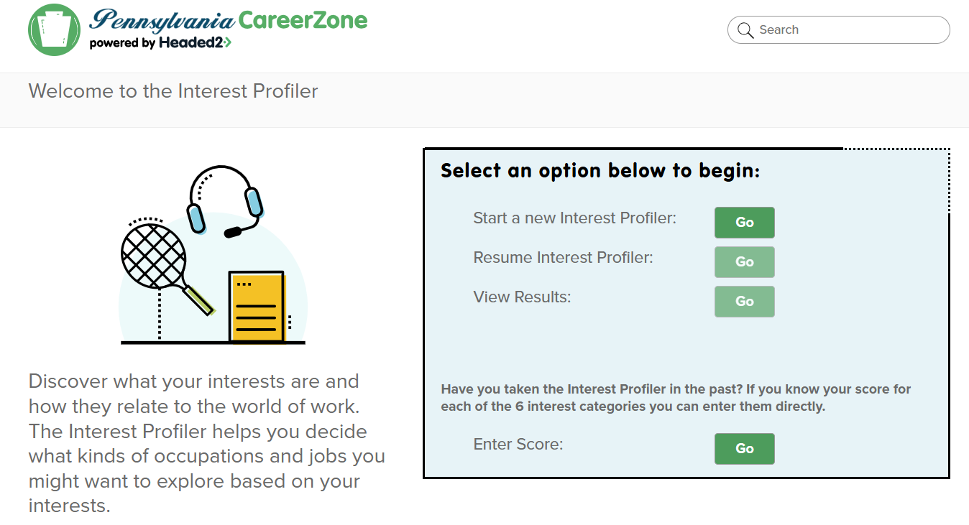

  - Click and complete the “60 Question – Short” option.

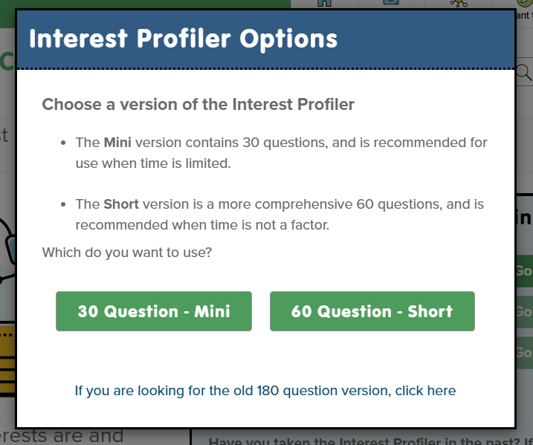

  - After completing the assessment, students will find an interest profiler summary. After clicking, “View Occupations,” students will find “Top Clusters” on the right of the results screen. Although the wording might be slightly different, these will correspond to the clusters listed below. Students should be assigned time to research the clusters before choosing which of the top results they prefer and enroll in that learning pathway on the Luzerne Learns to Work ‘Learn More’ page. (15 minutes).

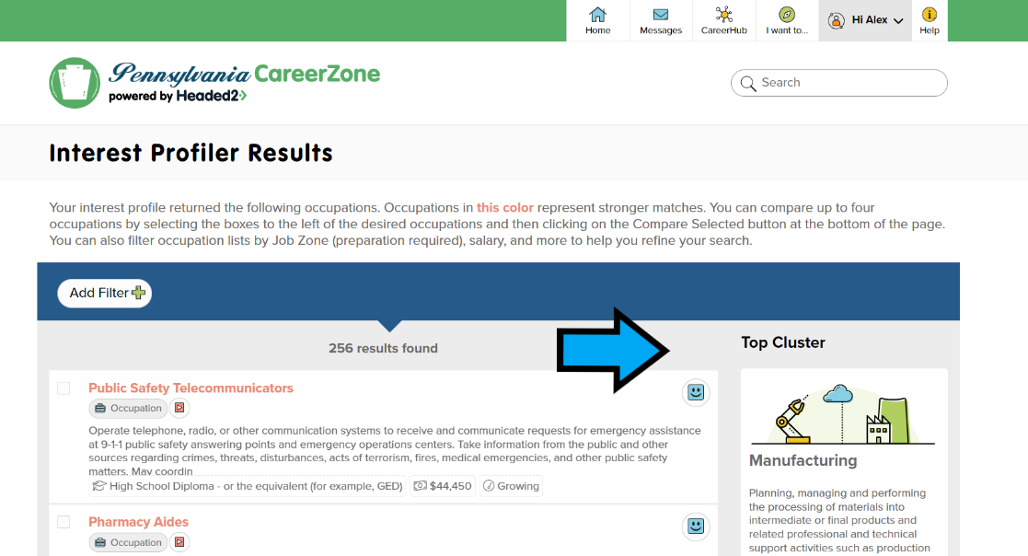

  - The following are career clusters in the program:
- Agriculture, Food & Natural Resources
- Architecture & Construction
- Arts, A/V Technology & Communications
- Business Management & Administration
- Education & Training
- Finance
- Government & Public Administration
- Health Science
- Hospitality & Tourism
- Human Services
- Information Technology
- Law, Public Safety, Corrections & Security
- Manufacturing
- Marketing
- Science, Technology, Engineering & Mathematics
- Transportation, Distribution & Logistics

  - After completing each of the previous steps, no other tasks are necessary for the Career Assessment portion of Luzerne Learns to Work.

Luzerne County Library Card (5-10 minutes)
- Residents of Luzerne County, including students, are entitled to a free library card from the Luzerne County Library System.
- To sign up for a library card:
  - Go to Luzerne Libraries and apply for a library card by completing the form and clicking ‘Submit’..
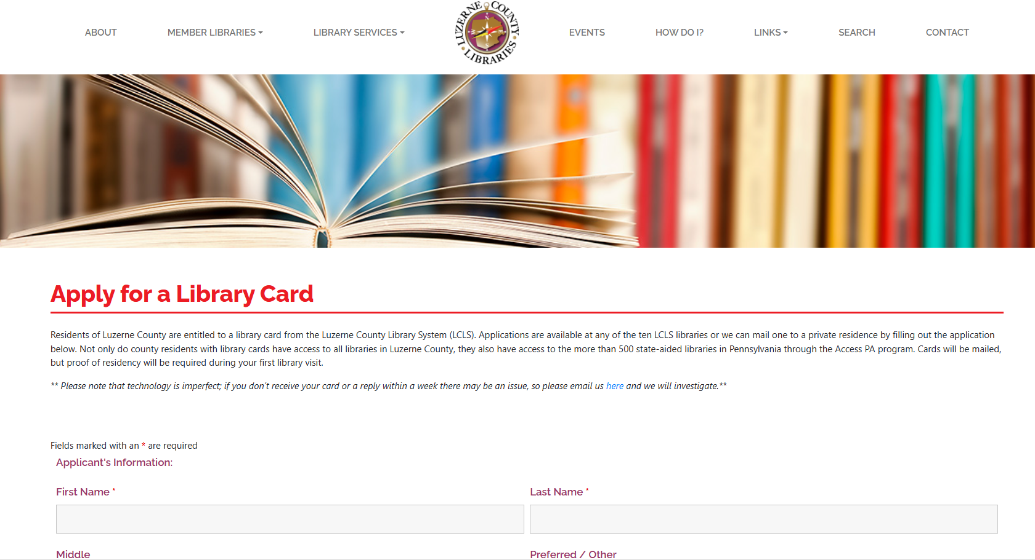
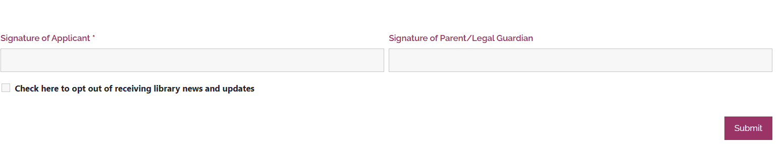
  - Having a library card now allows the student to login to and take the AMA MicroCourses listed under the Career Clusters tile on the Luzerne Learns to Work ‘Learn More’ page.

- Onboarding and Completing Pathways
EBSCOlearning/LearningExpress Library/AMA MicroCourses (1 hour)
- EBSCOlearning is a source for test preparation, skill building, and career resources for students, educators, and adult learners.
- AMA MicroCourses is a part of the EBSCOLearning, LibraryExpress Library where students start building in-demand skills with micro-courses from the American Management Association.

Onboarding Students and Tracking Student Progress
- To onboard students to AMA MicroCourses (10 minutes):
  - Students create a login at AMA MicroCourses®
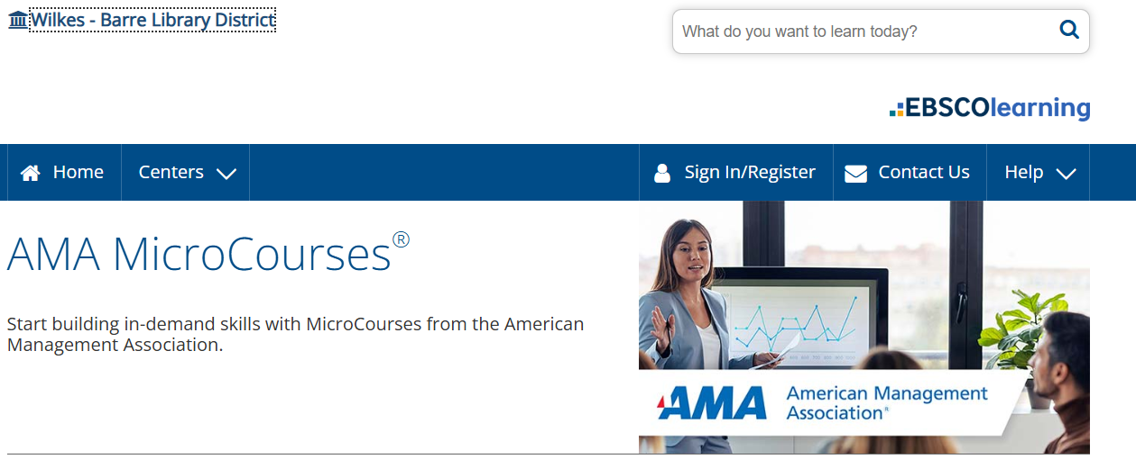
  - Once logged in, the student should refer to Luzerne Learns to Work ‘Learn More’ page and scroll down to the Learning Pathways. Here they select their Career Cluster/Industry.
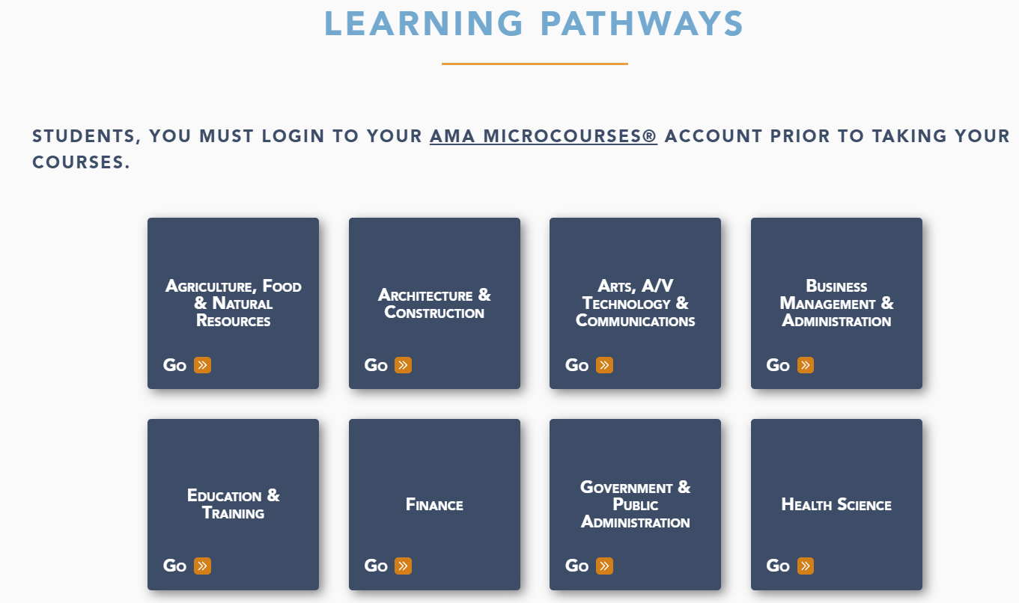
  - Once the Career Cluster/Industry is selected, the learning pathway will open and display all the courses required to complete that pathway. [Before being able to take the courses, the student must first login to the AMA MicroCourses®, then return back to the career pathway where they can click on each course to launch the learning module.] (NOTE: Students must be logged into the AMA MicroCourses before launching and taking the courses listed within the Career Cluster/Industry depicted below.)
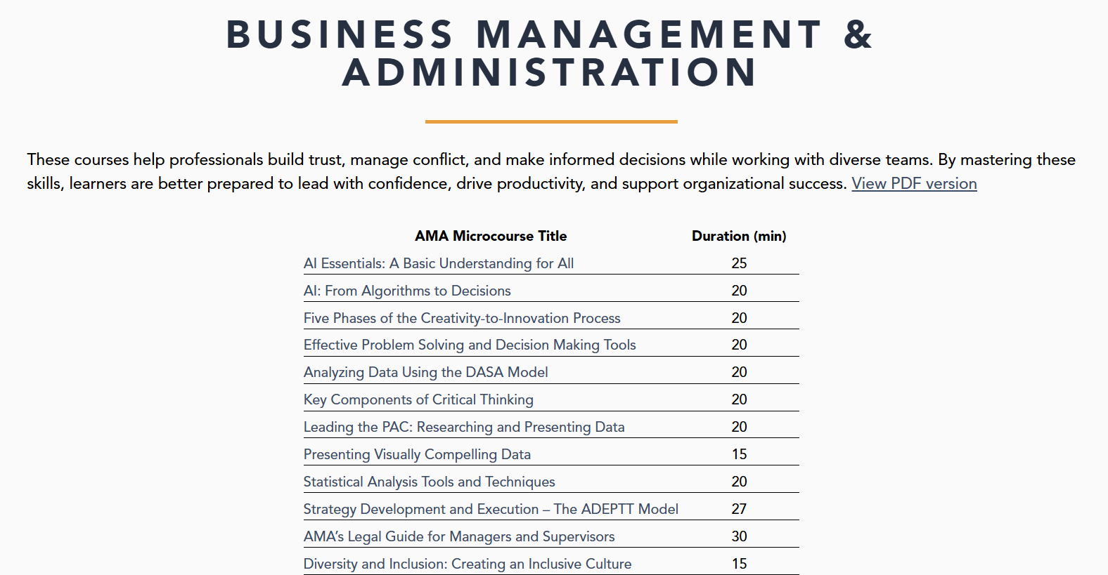

  - The student can begin taking the courses and print the certificate for each course upon completion.

Teachers’ Tasks:
    - It is recommended that teachers create a schedule that will enable students time to complete the courses. (Ex: Complete these courses during our career exploration time in class, homework, etc.)
    - Add a due date of when you want your students to complete the learning path by.

- Additional Learning Opportunities
CareerLink SkillUP/Metrix Learning (15-20 minutes)
- PA CareerLink® is a state government program that provides career services to employers and employees in Pennsylvania. Students should register in order to access a variety of career tools. PA CareerLink® also provides free online courses through the Metrix Learning Portal. The program was created to help Pennsylvania residents strengthen their job skills to be competitive in the current employment market. While this is not a requirement of Luzerne Learns to Work, we encourage students to explore this region.
- To register with PA CareerLink® and Metrix Learning:
  - Visit the PA CareerLink® website at PA CareerLink® - Welcome to PA CareerLink
  - Register as a new user (begin by clicking the option on the top right of the page).
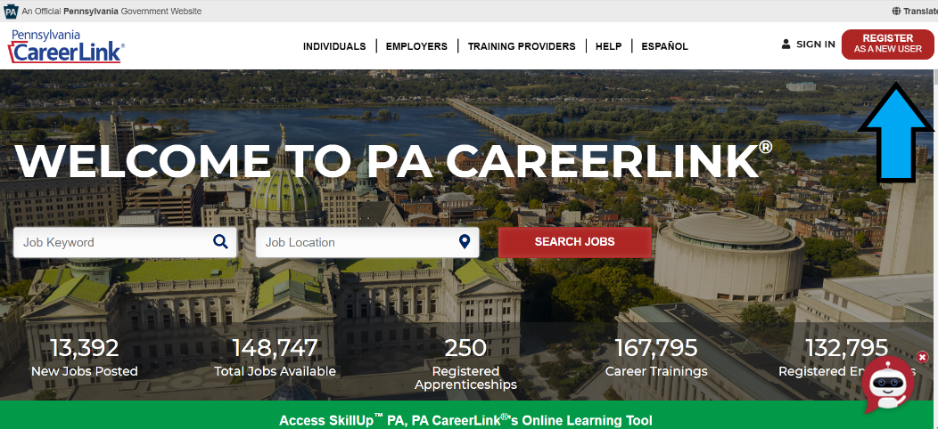

  - Select “Individual Seeking Other Services” and fill out the form. Make sure to answer “No” to the question, “Have you applied for, or are receiving benefits or services?” This will eliminate the need for a social security number.
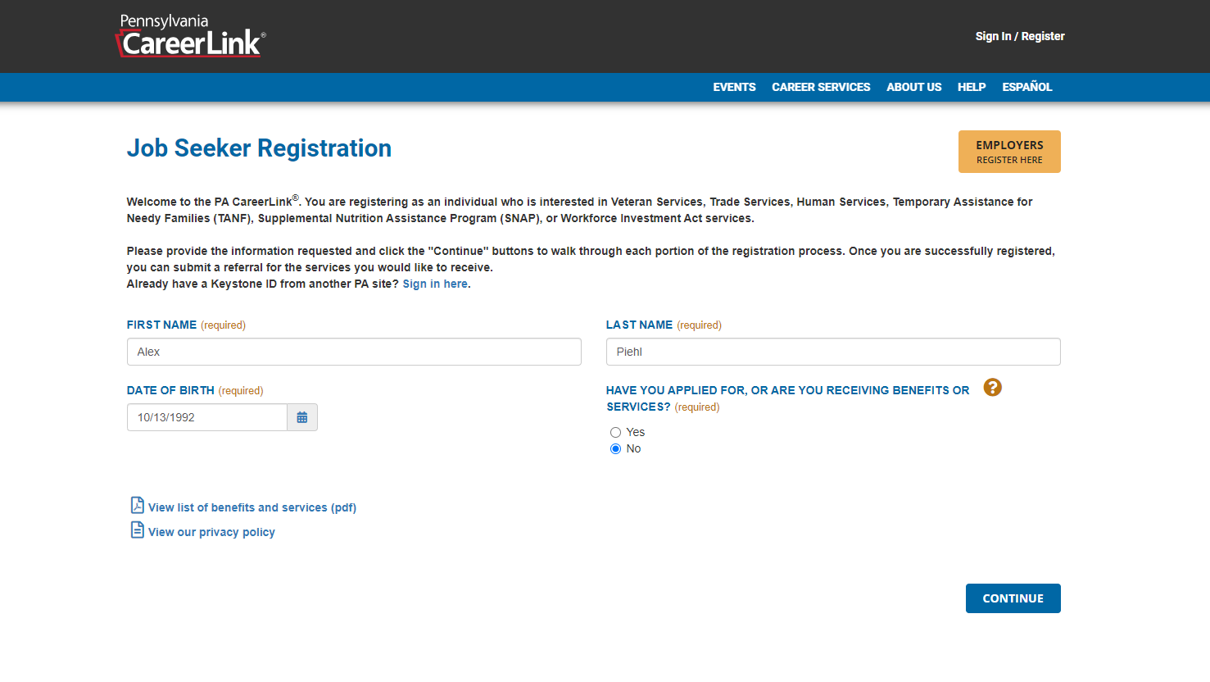
  - Complete the pages asking for ‘Contact Information’ and to ‘Create a User Account’ (Keystone ID).

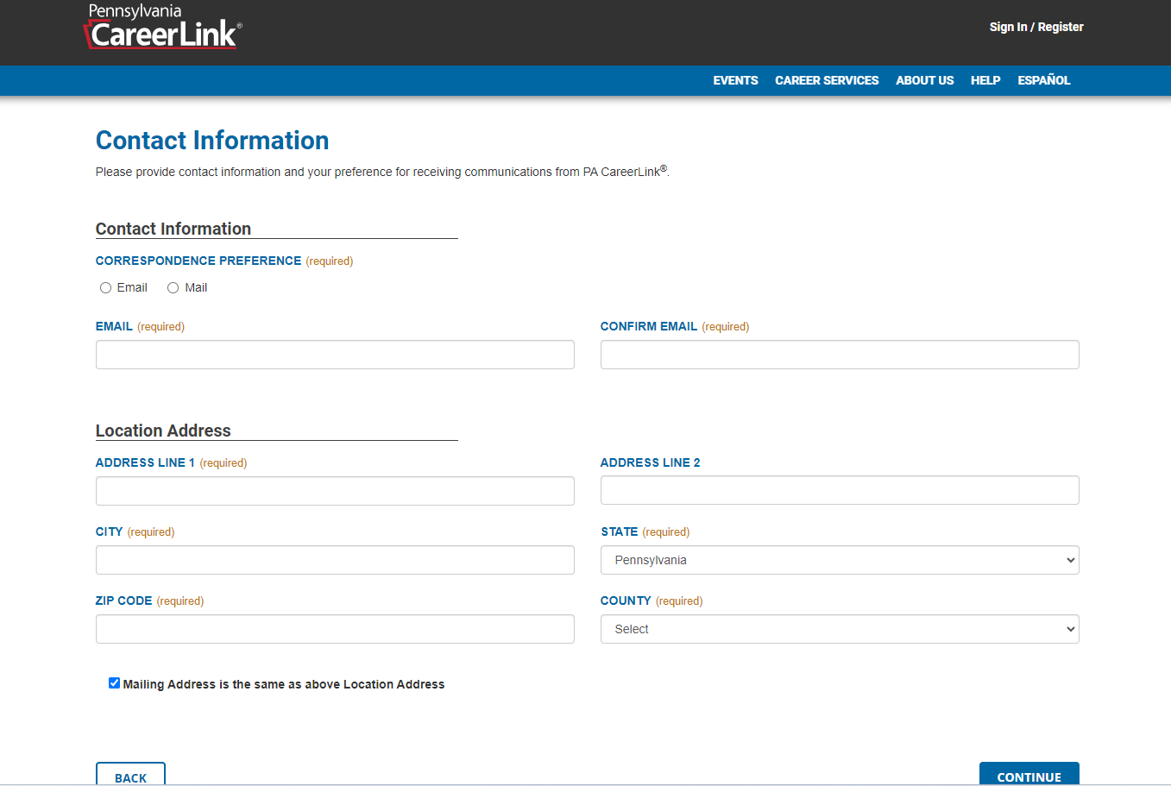
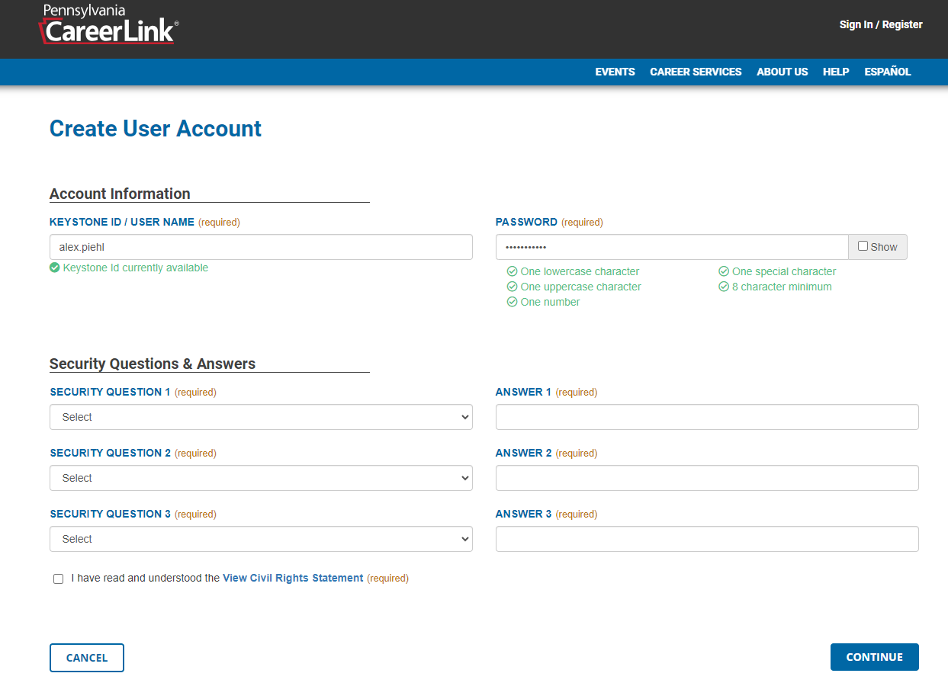

  - When registration is complete, sign-in and select the green bar to “Access SkillUP PA, PA CareerLink®’s online learning tool.”
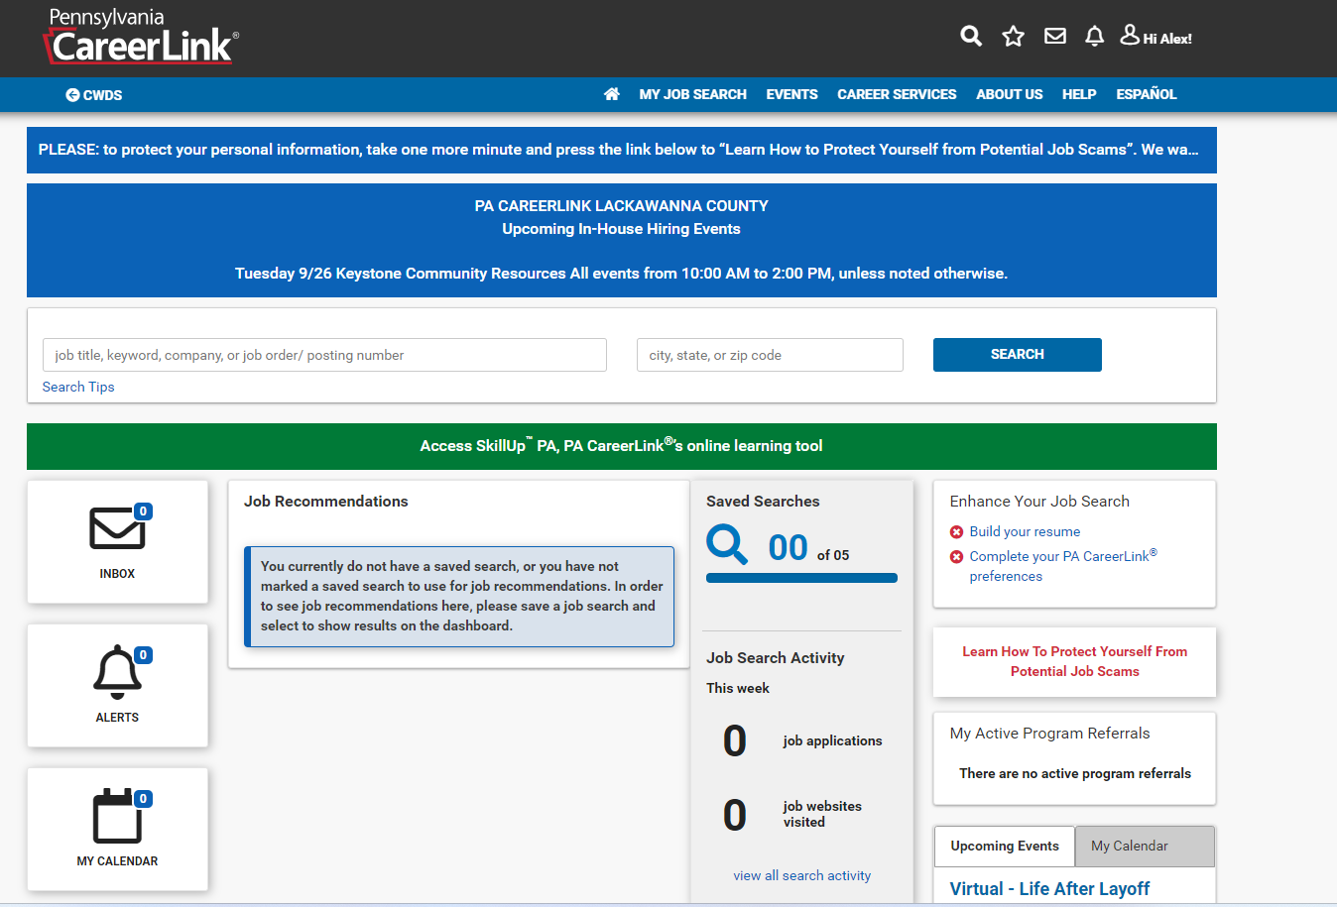
  - Click “Continue” on the Disclaimer pop-up to proceed to the Metrix Learning Portal. If the student receives an additional message asking them to select the business partner that referred them to Metrix, select “None of The Above.”
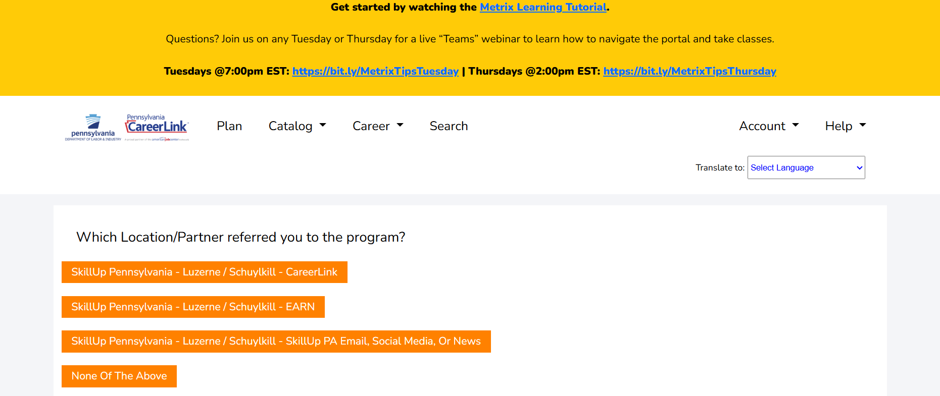
  - A prompt will appear, requiring the student to create a new password.
  - An email will be sent to the student with a link to the Metrix Learning Portal and user credentials for future reference. The student will now be able to access Metrix.

- Having an account on PA CareerLink® now allows the student to take Metrix Learning courses that will complement the AMA MicroCourses in the student’s learning pathway.
- Students should save their log-in information in a safe place to use again in the future.

Metrix Learning Courses
- As previously noted, optional courses are made available through Metrix Learning/PA CareerLink®. Students are welcome to browse Metrix and take courses of their choice.
- From the Metrix Learning homepage (Metrix Learning | Official Home Page), students should click the “Catalog” drop-down and then select “Browse”.
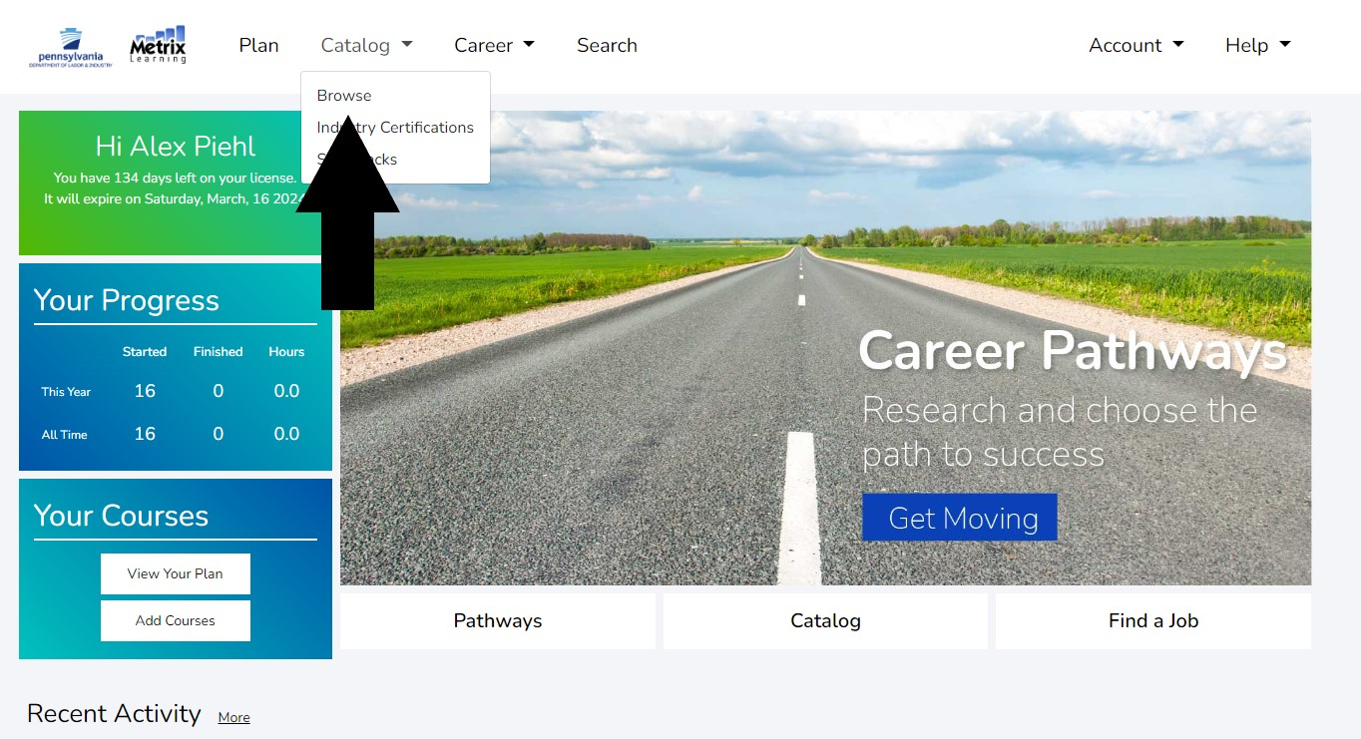
- Students interested in learning more about a topic outlined in their AMA MicroCourse, such as AI, Statistical Analysis, Critical Thinking, etc. should type the topic in the “Search For…” bar and select “Go.” In the example below, the course of interest being used is “Analytical Thinking”.

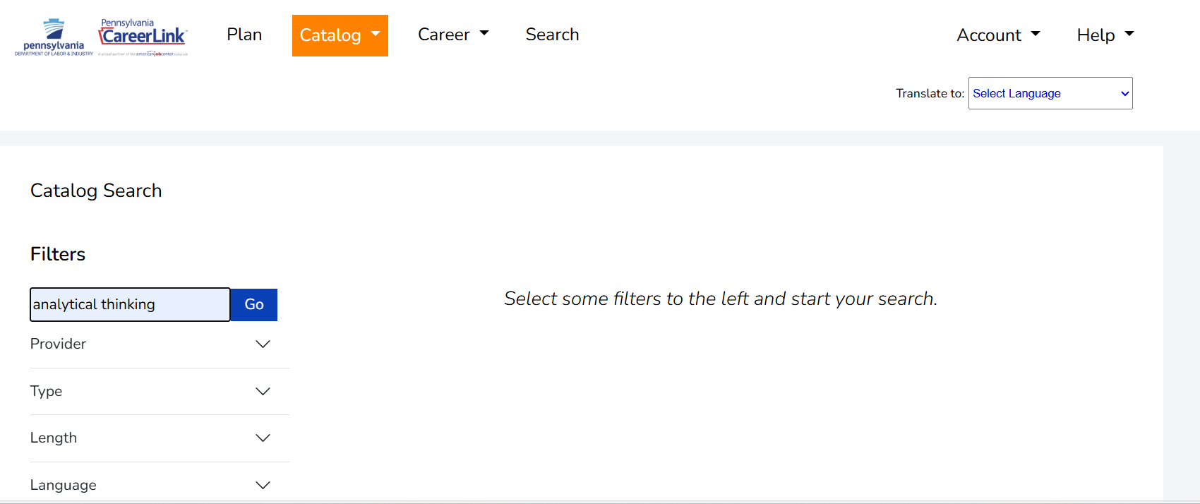

- The student should select ‘Go’ and the courses that appear will provide the student with learning opportunities that are in addition to what the student learned in the AMA MicroCourse. This is optional and will be based upon the student’s interest in learning more about a subject matter.
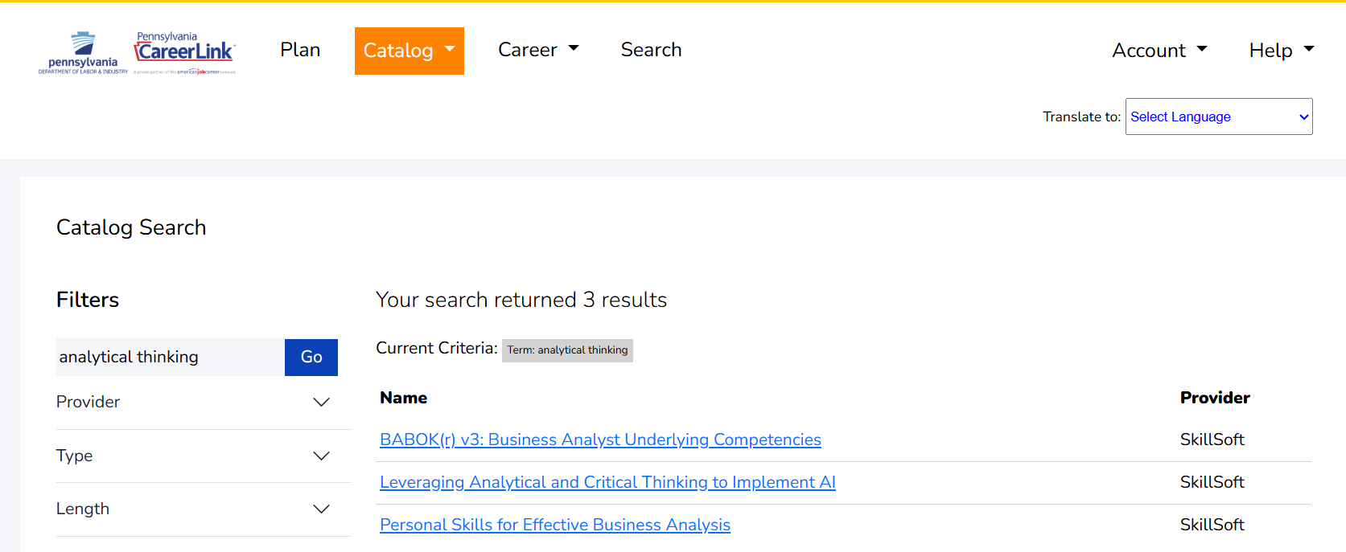

- After selecting the course, a box with course details will appear. At the bottom of this box, select “Add To My Plan”.

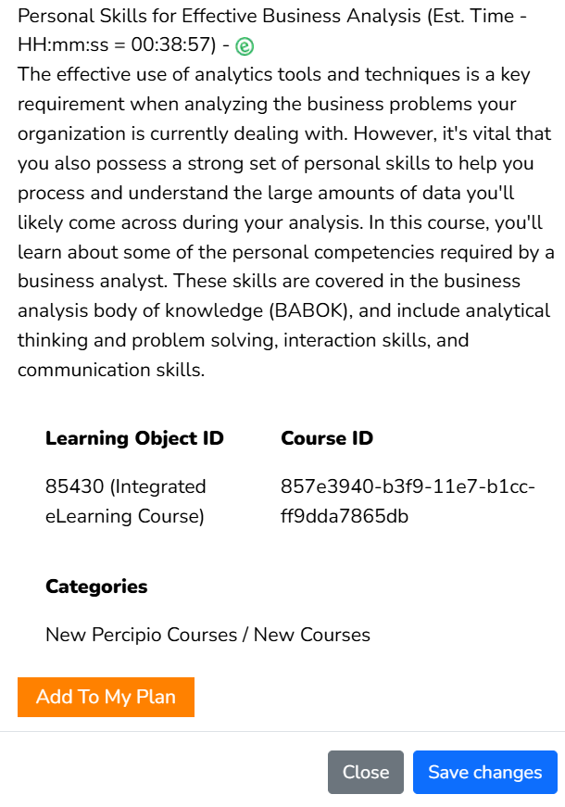
- On the next page, click ‘Submit’.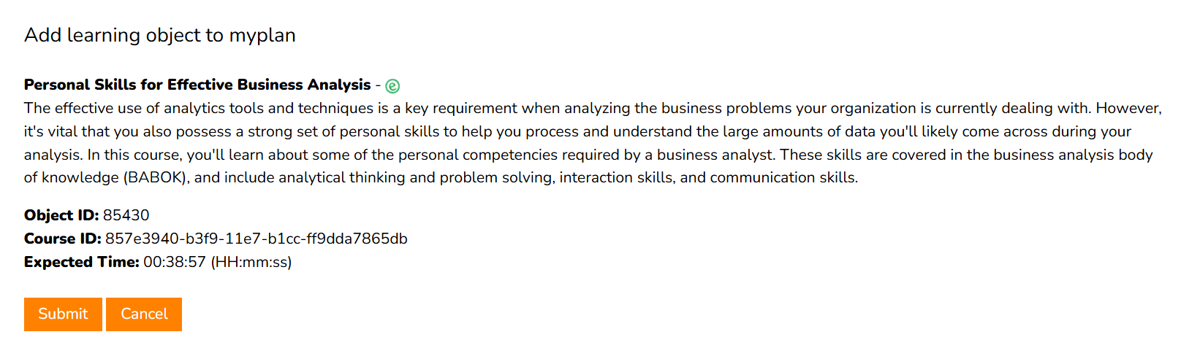

- From here, select “Plan”. The relevant course should now appear under “Courses.” The student should then click on the name of the course. After clicking this, the course will launch.
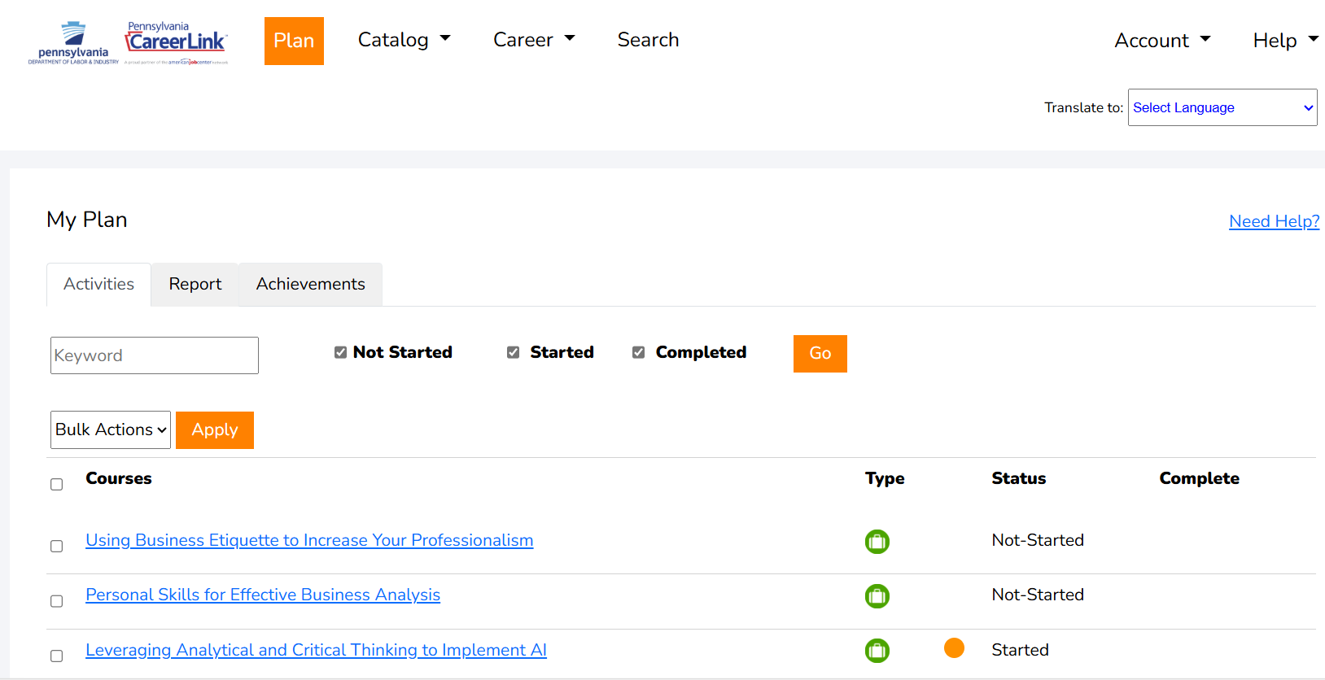

- Work-Based Learning Experiences
- As students take courses, they will also explore the database of work-based learning experiences offered by local employers through the Luzerne Learns to Work portal under ‘Do More’.

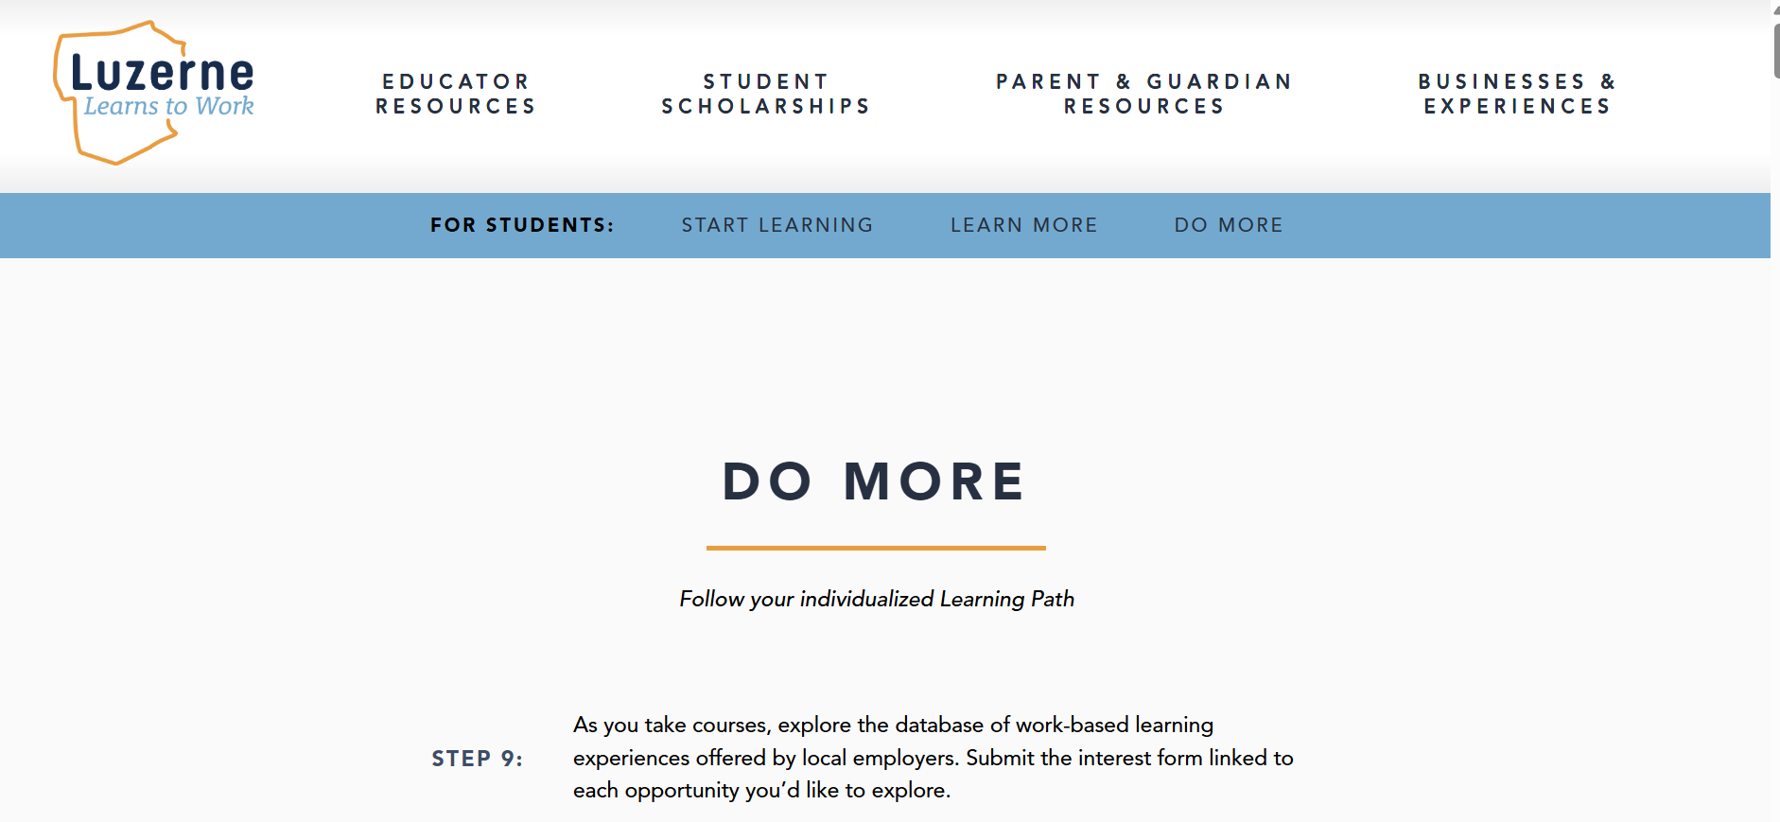

- After submitting the interest form linked to each opportunity they would like to explore, students will attend work-based learning experiences to see real-world application of their new skills in local industries.
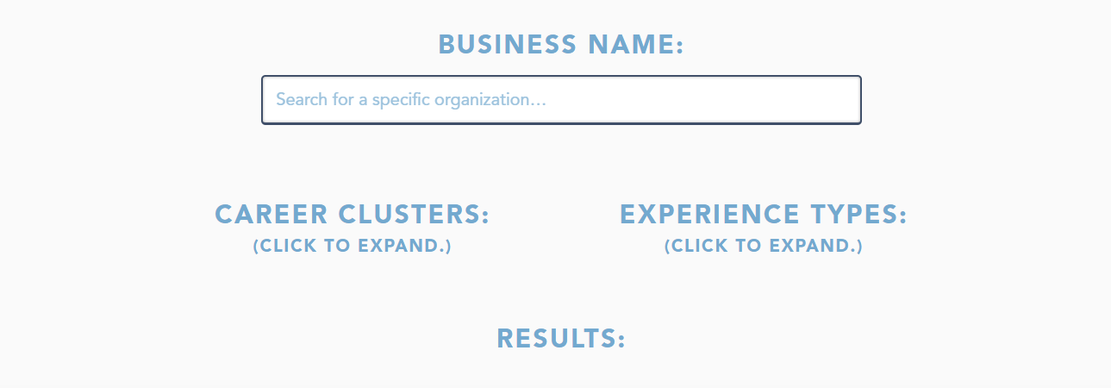
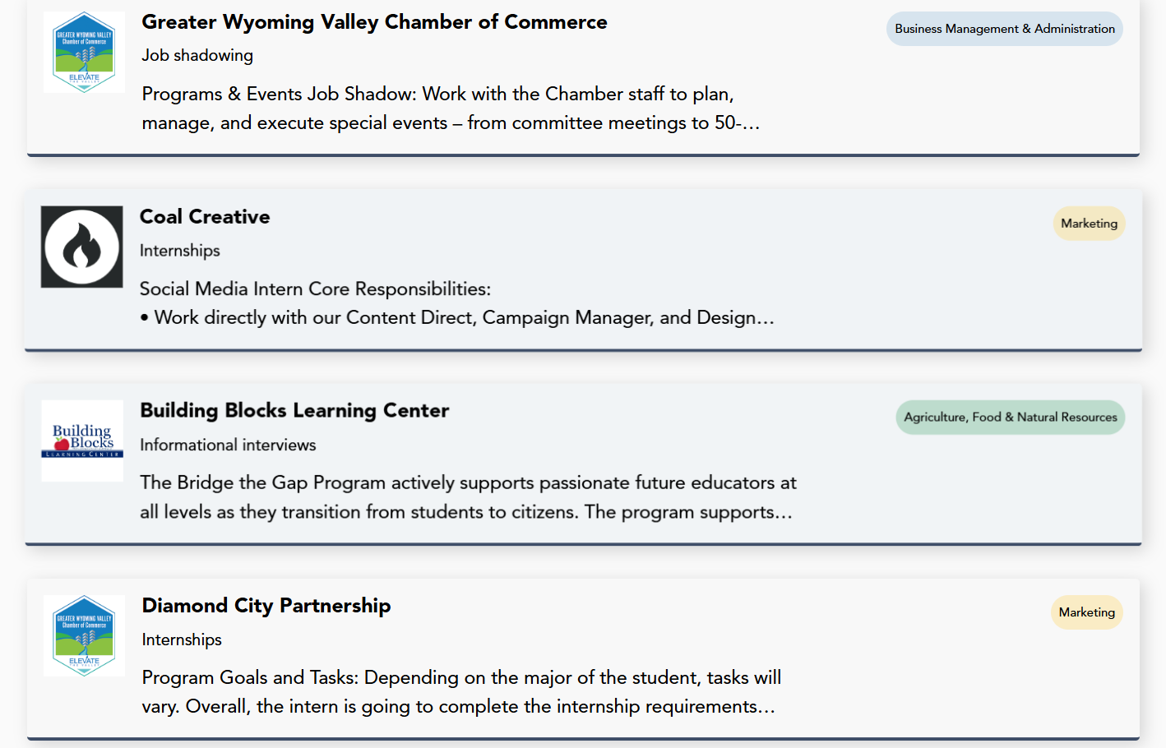
- Continuing Education and Scholarship Opportunities
  - Students can explore degrees and certifications to help them pursue their career interests. These can be found on the Luzerne Learns to Work ‘Learn More’ page.

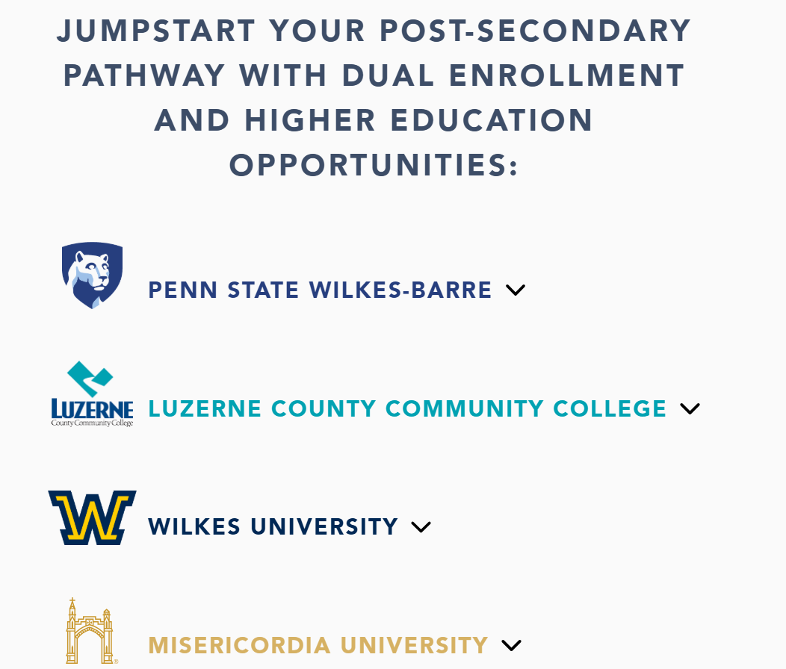

- Students can also apply for the Luzerne Learns to Work Scholarship located under ‘Student Scholarships’ in the top section of the Luzerne Learns to Work site. The application window for the 2025-2026 academic year will be open from Jan 1st – March 31st, 2026.
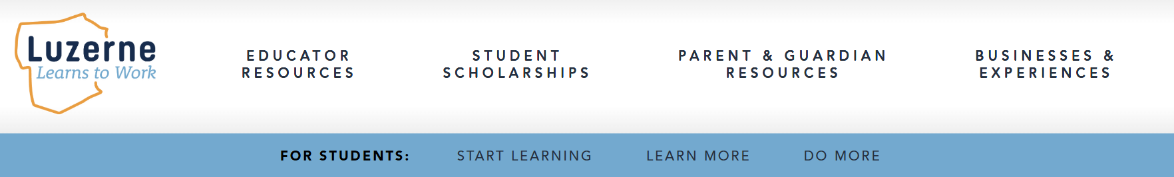
- ELIGIBILITY:
  - Must be a senior in a Luzerne County high school.
  - Have completed a learning pathway through the Luzerne Learns to Work program.
  - Have completed (or are registered to participate in) at least one (1) local work-based learning experience.
  - Will be pursuing post-secondary education at an accredited institution in Luzerne County.
- USE OF FUNDS:
  - Funds can be applied to college tuition, training program enrollment, workforce training, certifications and continuing education, etc.
  - Scholarships are dependent on college/training program enrollment, and funds will be paid directly to institutions.
  - Awarded funds must be applied within one (1) year of scholarship award.
- APPLICATION:
  - Applicants are required to fill all question fields as completely as possible.
  - Applicants are required to prove completion of their learning pathways by uploading completion certificates for all courses at time of application.
  - Applicants must certify accuracy and validity of all responses, including that they meet the above eligibility criteria.
  - Applicants must complete the student feedback survey as a part of their application.
- The review and evaluation process will take place in April, and scholarships will be awarded in May.

Sample student work sessions and exploratory research opportunities
Students can be given smaller “filler” assignments, such as the examples below, to be completed throughout the program as they complete their learning pathways. Note: these are simple and flexible things to have students work on with substitutes or on days you’d like them to do independent research or exploration.

  - Watching the career cluster videos (30 minutes)
    - Writing a summary of one that interests the student.
  - Exploring the companies in the work-based learning database (30 minutes)
    - Researching one of the companies and submitting a paragraph on what they do, etc.
  - Research the higher education opportunities for the student’s pathway of interest
    - Write a summary of a program of study at an institution that a student is interested in.

